Aim: CSS Programming

Practical 4

1. Basics of CSS programming Practical: Class, Id, changing proper es like color, size, background etc.
2. CSS 3 Programming Practical: shadow, orienta on, transforma on, gradient etc.
3. Positioning practical in CSS: Absolute and relative positioning, Z-index.

 Basics of CSS programming Practical: Class, Id, changing proper es like color, size, background etc.

 HTML Code:

<html>

<head>

< title> Registration form </ title>

<link rel="stylesheet" href="style.css">

</head>

<body>

<h1> Registra on form </h1>

<form method="get" ac on="#">

<fieldset>

<legend> Personal Details </legend>

<p><label>First name</label><input type="text" name="fname" placeholder="First name" required autofocus autocomplete="off"></p>

<p><label>Middle name : </label><input type="text" name="mname" placeholder="Middle name" autocomplete="off"></p>

<p><label>Last name : </label><input type="text" name="lname" placeholder="Last name" required autocomplete="off"></p>

<p><label>Email-ID : </label><input type="email" name="email" placeholder="Enter email ID" required autocomplete="off"> </p>

<p><label>Phone number : </label><input type="tel" name="number" placeholder="Enter personal phone number" max-length="10" required autocomplete="off"></p>

<p><label>Office number : </label><input type="tel" name="number" placeholder="Enter office phone number" pa ern="[0-9]{6}" required autocomplete="off"></p>

<p><label>Password : </label><input type="password" name="pass" placeholder="Enter 6 digit pasword" required autocomplete="off"></p>

<p><label>Age : </label><input type="number" name="age" placeholder="current age" min="18" max="100" pa ern="[0-9]{2}" required autocomplete="off"></p>

<p><label>Gender : </label><input type="radio" name="bu on" checked="select">Male<input type="radio" name="bu on">Female</p>

<p><label>Hobbies : </label><input type="checkbox" name="checkbox">Music<input type="checkbox" name="bu on">Write a book <input type="checkbox" name="bu on">Singing<input type="checkbox" name="bu on">Swimming</p>

<p><label>Address : </label><textarea rows="4" columns="20">Anand</textarea></p>

</fieldset>

<hr>

<form method="get" ac on="#">

<fieldset>

<legend>Educa onal Qualifica on</legend>

<p><label>College Name: </label><select name="college">

<op on selected disabled> -- Select College -- </op on>

<op on value="GCET"> GCET </op on>

<op on value="adit"> ADIT </op on>

<op on value="mbit"> MBIT </op on>

<op on value="bvm"> BVM </op on></select>

<p><label>Branch : </label><input type="radio" name="bu on" checked="select">CP<input type="radio" name="bu on">CSD<input type="radio" name="bu on">IT<input type="radio" name="bu on">IOT</p>

<p><label>Admission Date: </label><input type="date" name="date" placeholder="Admission Date"></p>

<p><b>College Time : &nbsp; From : <input type=" me" name=" ime"> &nbsp; To :

</b><input type=" me" name=" me">

<p><label>Web Development lecture Day : </label><select name="lecture" mul ple>

<op on selected disabled> --Select Days-- </op on>

<op on value="mday"> Monday </op on>

<op on value="tday"> Tuesday </op on>

<op on value="wday"> Wednesday </op on>

<op on value="thday"> Thursday </op on>

<op on value="fday"> Friday </op on>

<op on value="sday"> Saturday </op on></select>

<p><label>Next Web Development Lecture Date : </label><input type="date" name="ldate" placeholder="Lecture date"> &nbsp; Lecture Time : <input type=" me" name="l me"></p>

<p><label>Upload image : </label><input type="file"></p>

<p><input type="Submit" value="submit"></p>

</fieldset>

</form>

</body>

</html>

 CSS Code: body

{

background: url("mountain.avif") no-repeat center center fixed; background-size: cover;

}

h1

{

text-align: center; margin-top: 14px; color: aliceblue;

}

legend

{ color: black; border- radius: 5px; font-weight: bold; margin: 5px;

padding: 5px 5px;

}

fieldset{ border-radius: 5px; margin: 20px;

}

label{ color: black; display: block; font- weight: bold;

width: 100%;

}

input[type="text"], input[type="textarea"], input[type="email"], input[type="tel"], input[type="password"], input[type="number"], input[type="textarea"]

{

width: 650px;

}

select{background-color:aliceblue;

}

input[type="checkbox"], input[type="radio"]

{

padding: 9px; cursor:

pointer;

accent-color: darkgray;

}

input[type="Submit"]

{

padding: 9px; width: 150px; font-weight: bold;

}

input[type="Submit"]:hover

{

cursor:pointer; background-color: gray; color: white;

}

hr{ margin: 50px;

}

form

{

border-radius: 9px; border: 2px solid white; width: 50%; margin: 0 auto;

background-color: rgb(240 240 246);

opacity: 0.9;

margin-bo om: 25px;

}

 Output:

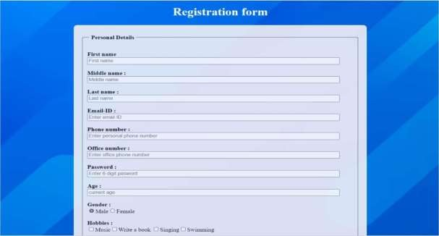



4.2 Code:

Html:

<!DOCTYPE html>

<html lang="en">

<head>

<meta charset="UTF-8">

<meta name="viewport" content="width=device-width, initial-scale=1.0">

<title>Card Example</title>

<link rel="stylesheet" href="styles.css">

</head>

<body>

<div class="card">

<div class="card-content">

<h2 class="card-title">Visiting card</h2>

<center><p class="card-description">Beauty Salon</p></center>

<p>Contact us on your special events<br>Book your slots and get the expierence of our expertise. </p>

</div>

</div>

</body>

</html> Styles.css body { display: flex;

justify-content: center; align-items: center; height: 100vh;

background:radial-gradient(circle ,orange 20%,red 78%); font-family: Arial, sans-serif;

}

.card {

width: 300px; height: 200px;

background: linear-gradient(178deg, blue, rgb(133, 63, 75)); border-radius: 15px;

box-shadow: 0 4px 8px rgba(0, 0, 0, 0.2); transform: rotate(0deg);

transition: transform 0.5s, box-shadow 0.5s;

}

.card:hover {

transform: rotate(-5deg) scale(1.25);

box-shadow: 8px 15px 5px rgba(0, 0, 0, 0.5);

}

.card-content { padding: 20px; color: white;

}

.card-title { font-size: 24px;

margin-bottom: 10px;

}

.card-description { font-size: 16px;

}

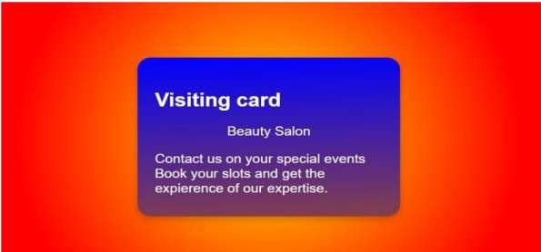Output:

4.3 Code:

<!DOCTYPE html>

<html>

<head>

<title>Z-index</title>

<style>

.container{ height: 300px; width: 500px;

border: solid black 1px;

}

#box1{

position: absolute; height: 80px; width: 80px; margin-top: 60px; margin-left: 60px;

background-color: red; z-index: 1;

}

#box2{

position: absolute; height: 80px; width: 80px; margin-top: 90px; margin-left: 90px;

background-color: blue; z-index: -1;

}

#box3{

position: absolute; height: 80px; width: 80px; margin-top: 110px; margin-left: 110px;

background-color: green; z-index: 3;

}

#box4{

position: absolute;

height: 80px; width: 80px; margin-top: 90px; margin-left: 210px;

background-color:chartreuse; z-index:2;

}

#box5{

position: absolute; height: 80px; width: 80px; margin-top: 110px; margin-left: 250px;

background-color:brown; z-index: 3;

}#box6{

position: absolute; height: 80px; width: 80px; margin-top: 130px; margin-left: 300px;

background-color:darkorange; z-index: 4;

}

</style>

</head>

<body>

<div class="container">

<div id="box1">Box1</div>

<div id="box2">Box2</div>

<div id="box3">Box3</div>

<div id="box4">Box4</div>

<div id="box5">Box5</div>

<div id="box6">Box6</div>

</div>

</body>

</html>

Output:

